# Untitled

# Event Management System Java Project

TCET

Mumbai

# Deeksha Rai (SE IT B) Abhishek Pandita (SE IT B) Prasad Nayak (SE IT B)

[raideeksha809@gmail.com](mailto:raideeksha809@gmail.com) [abshek2109@gmail.com](mailto:abshek2109@gmail.com) [prasadnayak17@gmail.com](mailto:prasadnayak17@gmail.com)

**Executive Summary**

**Event management system is used to manage all the activity related to event.In any event many services providers work simultaneously and it is very hard to manage these providers. It is also important for event organiser that he has all the contacts deteails of these prticipants so that he can contact them at any point of time.**

**Event Management System (EMS)** is developed as a web-based application developed in Java programming language. It facilitates [online registration](https://www.codewithc.com/civil-registration-system-asp-net-project/" \t "https://www.codewithc.com/event-management-system-project-java/_blank) cum feedback evaluation for different kinds of events such as games, workshops and seminars. The project’s main objective is to control or manage the activities and duties to be performed by various event conductors such as attendees, organizers, event reviewers and authors.

Proper event management planning is vital for any successful event. The EMS is the document that establishes how all the distinct moving parts and disparate elements of your event will work and result in your event being safe and enjoyable.

**Problem Statement**

To build a Event Management System to schedule entry in college fests, events and seminars. The student should be able to view their event schedules and also to cancel or delete the registration. Student should be able to register themselves for meeting. Design a program to assist in strategic planning and help to ensure that the organization is equipped with the right level of information and details of future goals. The system should ultimately allow you to better manage resources.

**Description**

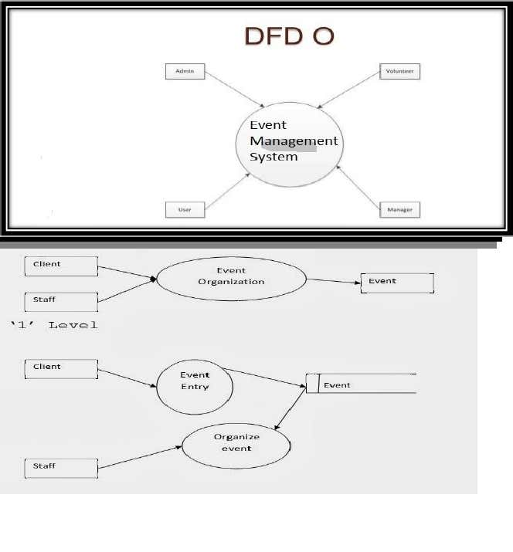This project performs the task of developing a web application that enables the students and faculty to retrieve the data very easily. The main purpose of event management system is to provide a platform for the users to view the information about the events that took place in the past and the ones which are about to take place in the near future. The users can be faulty, students and administrator. They can first login into the website and see through the information such as details about the events like the venue, theme of the event, participants, chief guests, etc. The faculty can keep the record of the attendance also. The administrator can login and update the information, delete any unwanted data, arrange the information accordingly so that the user can go through an user friendly and know all the whereabouts of their college.

**Findings**

The scope of the project is just limited to a laptop or a pc with an internet connection. Firstly, the user, whoever it may be (student of faculty) need to register to the website. After the registration process is completed each one of them gets a password and have their own user ids. With these two they can access their account and for any query they can contact the administrator by sending him a mail.

* Facility to schedule a meeting.
* Facility to see participants engagement's dairy
* Facility to invite participants over mail
* Facility to let know if canceled the Event
* Participants option for denying the invitation
* User registration
* Administrator privilage to edit user's profile

**Implementation**

Proposed online student registration system will eliminate all the manual intervention and increase the speed of whole process.   System will allow student to fill the form online, system has inbuilt validation system to validate the entered data. After successful submission, system will give unique registration ID for each student. Student can login into system by using this registration ID and can give online feedback. System will generate the result instantly and store the results for further use.

Improve management productivity, satisfaction and retention by Eliminate paper trails and manual process with complete online management for handling management for registration of events.

Manage all students’ information easily in comprehensive students record that includes student’s information. Simply Event Management System with easy record management. Faculty can easily manage the attendance of the students who are participating in certain events.

**Event   Management   System** (**EMS**) is a web-based application that supports online registration and feedback evaluation for event training programs such as games, seminars and workshops. It helps program attendees, organizers, the authors and the reviewers in their respective activities.

Development of Event management system is an attempt to address the problems of managing registration forms, feedback forms and evaluating feedback. The main goal of this software is to give working solution to store, manage and consolidate the registration data and the feedback data.

EMS is web-based system for collecting registration forms and evaluating the feedback automatically. It increases the scope of the report generation even by generating report over a period of time.

Typical functions supported by TMIS are:

* Registering students participants
* Getting attendance from faculty
* Collecting feedback from students
* Generating feedback reports.

### System Requirements:

1. Software Specifications:

* Technology     : Java, jdbc and jsp
* Database         : MYSQL
* OS                    : Windows XP
* Browser          : Internet Explorer 7.0
* Web Server    : Tomcat Apache 5.0

2. Hardware Specifications:

* HDD                  : 512MB
* RAM                  : 256MB
* Micro Processor Pentium-p4
* Keyboard
* Mouse

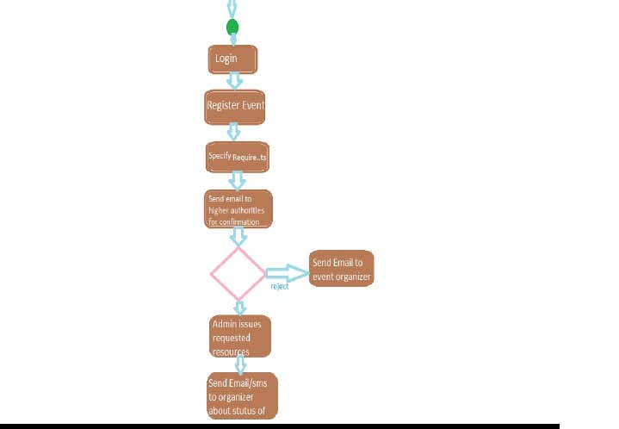

**Discussion**

Event Management System being a web-based project, it is very simple, easy to use and flexible. The key features or functions of the project are:

* Registration of participating students
* [Scheduling meeting](https://www.codewithc.com/appointment-scheduler-asp-net-project/" \t "https://www.codewithc.com/event-management-system-project-java/_blank)
* Inviting participants via [email](https://www.codewithc.com/email-client-software-java-project/" \t "https://www.codewithc.com/event-management-system-project-java/_blank)
* Canceling events
* Collecting [feedback from students](https://www.codewithc.com/student-assignment-feedback-system-php-project/" \t "https://www.codewithc.com/event-management-system-project-java/_blank)
* Recording attendance details from faculty members

**Input Study**

The EMS is easy to use, full-featured and flexible participant registration and feedback   assessment web application.

**FACULTY** does login, register, and view events, view register students, logout

**MODULES IN THE PROJECT:**

Students

Faculty

Administrator

**ADMINISTRATOR** does login, upload events, and verify events registration form, logout.

Use cases:

Login

Upload events

Delete events

Verify events registration

**A STUDENT does** login, registration, view events, events registration, event status, logout.

**FACULTY** does login, register, and view events, view register students, logout

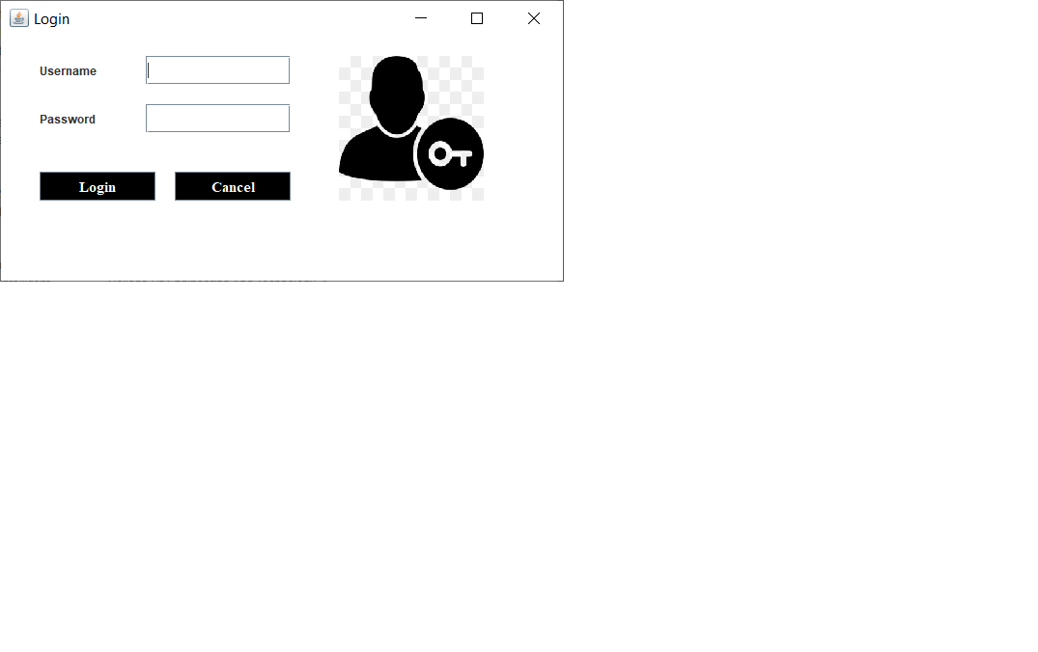

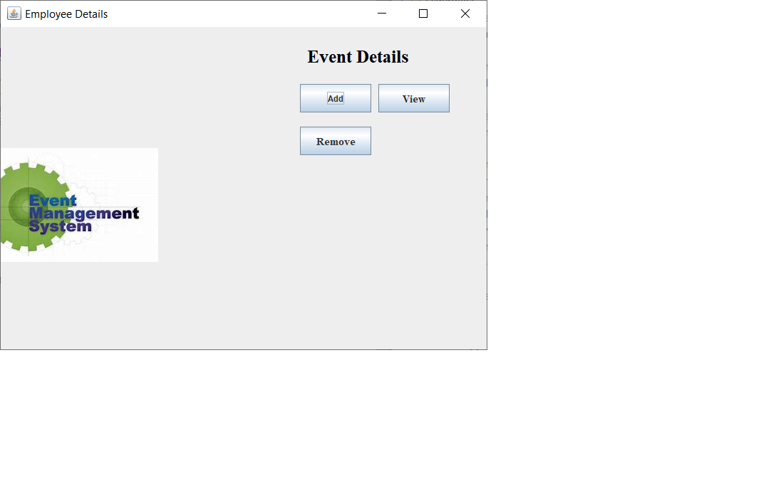

**Conclusion:**

The development of this Event Management System Project is to address and eradicate the problems in the current event management procedure. Here, management of registration form, receiving feedback forms, and evaluation of feedback is done very efficiently as a result of which the project has a good scope. “Event Management System” has been designed and tested. Integrating features of all the software components used have developed it. With the help of growing technology, the project has been successfully implemented. Project will definitely reduce the human effort and make the task of user, customer and administrator easier. It is efficient to use and easy to work on it. Thus keeping in mind the advantages and applications.